**CNT 5106C Computer Networks, Spring 2022**

Instructor: Prof. Ahmed Helmy

Homework 2: Application Layer Continuation and Transport Layer

[A *lab* part will be added later to this homework to intro socket prog.]

Instructions: Be precise and to the point. Read the hints. Many questions require answers using a few sentences. Some questions will ask you to elaborate, use visual aids or graphs. Use your own words/expressions, or graphs. Do not copy from any other source.

Q1- DNS-related: Consider a scenario of a user browsing the web from the machine storm.cise.ufl.edu, accessing an article in a website at URL:

www.nytimes.com/2019/09/26/technology/ai-computer-expense.html

The user performs three accesses: - using http, - using https and - using port 8080.

1. Show the sequence of DNS servers queried to resolve the URLs (assume no caching)
2. Write the complete URL for each of the three accesses [you may have to edit the URL]
3. Write the four tuple [src address, src port, dst address, dst port] for each of the accesses

A1-  
 A. The machine first queries the root DNS server to find the .com DNS server. After going to the com server it is then directed to the authoritative DNS server which in this case is the nytimes DNS server from where it gets the IP address of the URL it is trying to access.

B. <http://www.nytimes.com/2019/09/26/technology/ai-computer-expense.html>  
 <https://www.nytimes.com/2019/09/26/technology/ai-computer-expense.html>

[http://www.nytimes.com:8080/2019/09/26/technology/ai-computer-expense.html](http://www.nytimes.com/2019/09/26/technology/ai-computer-expense.html:8080)

C. HTTP- [10.3.0.229,3930, 151.101.1.164, 80]  
 HTTPS- [10.3.0.229,8612, 151.101.1.164, 43]

Using port 8080 - [10.3.0.229, 8612, 151.101.1.164, 8080]

[Hint: To get IP addresses use networking tools, like ping, traceroute, nslookup, ip address, etc.]

Q2- Discuss how the following technologies (or their variations) help in improving the performance of content distribution networks (CDNs):

1. HTTP
2. DNS

A2- HTTP:  
 A variation of HTTP known as DASH (Dynamic Adaptive Streaming over HTTP) is used in improving the performance of CDNs. What DASH does is that it allows the server to divide a file into chunks and each of those chunks can be stored at different bit rates to serve screens of different resolutions and keeps all this information in a manifest file which provides the URLs for these chunks. Thus, based on the bandwidth of the connection between the client and server the client can then request the appropriate coding rate from the server by referring to the manifest file. DASH achieves scalability by pushing the intelligence towards the clients rather than servers.

DNS:  
DNS also helps small startups who do not have their own CDNs to redirect traffic to a third party CDN. So, when the user requests for a video to the startup’s server, the server returns the URL to the user which is then resolved using the local DNS. The local DNS redirects to the authoritative DNS of the company which further redirects to another authoritative server of the CDN provider. This DNS server finally gives the pointer to the user where the actual file which he wants to stream is. Thus, DNS allows for redirecting traffic between different companies and allows smaller companies to use third party CDNs without letting the user know of the insides.

[Hint: Write a one paragraph of ~4-6 lines/sentences on each technology]

Q3- Elaborate on the data ‘*push*’ vs ‘*pull*’ in the context of

1. http vs SMTP
2. peer-to-peer network hierarchy communication (e.g., super nodes, group leaders)
3. Proxy and web caching
4. CDNs

A3-

1. SMTP is a push protocol where the user can push the mail messages to the mail server. The receiver’s user agent (ex: outlook) then pulls the mail from the mail server.

Whereas HTTP is a pull. When a client requests a file from a server it sends a request to the server and pulls the file from the server towards itself.

1. In a hierarchical P2P network, the group leaders establish a TCP connection with the group members and other leaders. The table of content is pushed by the group members towards the leaders ahead of time, even before a file is requested. When a user requests for a file, instead of going to each member the group leader can give a pointer towards the file if its group has it or ask other group leaders.
2. Web caches/Proxy Servers act as both client and server. When a user requests some file from the proxy server the proxy server pulls the data from the origin server and then serves the user. The user pulls the data from the proxy server. When the next user arrives and asks for the same file he pulls it directly from the proxy server as it already has a copy of it.
3. In a CDN multiple copies of videos are distributed at multiple different geographical sites. The origin server pushes files to servers located near the users based on the trends of the people living in that area. So when the user requests for a file, the user pulls from the server located closest to him or which offers the best performance.

[Hint: Write a one paragraph of ~4-6 lines/sentences on each point]

Q4- Someone suggested to use a local file called *hosts.txt* on each machine instead of DNS. Discuss the advantages (at least 2) and disadvantages (at least 2) of such suggestion.

A4- Disadvantages: The file hosts.txt will be static. So whenever there is a change in the network this file would have to be manually updated in each host connected to the network.  
Another disadvantage is that if a server is busy the user wouldn’t be able to contact another server for the same content. Hosts.txt file wouldn’t change from location to location either so if a person is accessing google from India or Germany they would still see the same content.  
Advantages: It can increase the browsing speed as the OS first looks for addresses in the hosts file and then the DNS server so if it finds the address in the hosts file it wouldn’t have to go to the DNS server thus reducing latency. It can also be used to block malicious websites.

Q5- What is ‘*saw-tooth*’ behavior in TCP, and what is causing it?

A5- One of the ways in which TCP achieves congestion control is through AIMD (Additive Increase Multiplicative Decrease). When there is no congestion, the network allows to increase the transmission rate linearly in small portions, but when it encounters losses/congestion then the transmission rate is multiplied by a fraction (which is usually 1/2), thus allowing for a more aggressive cut down on the congestion window size. Again, when there is no congestion, the rate is increased linearly and as soon as loss is experienced it drops down multiplicatively. When a graph is drawn of congestion window size vs time the figure looks like a saw-tooth, which is where it gets its name from.

Q6- A TCP flow and a UDP flow share a bottleneck link. Discuss the packet rate dynamics if the link gets congested, and comment on the eventual result. [Write a paragraph of ~4-6 sentences]

A6- TCP is a reliable protocol which provides congestion control, flow control, can limit its rate of transmission depending on the state of the network and also loss recovery. However, no such thing happens with UDP. So, when UDP and TCP are flowing in a bottleneck link, if they exceed the capacity of the network both will experience losses. However, TCP will slow down its transmission rate, cut down its window size, perform slow start, will receive duplicate acknowledgements, all to recover the lost packets whereas UDP will keep on going as it is an unreliable protocol which provides no loss recovery. As a result, it will get a larger share of the bandwidth as TCP will keep taking a step back to recover the lost packets.

Q7- TCP is supposedly fair, dividing the bandwidth between competing TCP flows. You want to transfer a huge file fast, suggest a way of doing so using TCP to get over the fairness delays, and approximate your new bandwidth share. The new share you will be getting may not be ‘fair’!

A7- Suppose there are already 9 existing connections sharing a link which has rate R which we will use to send our file. If we open one TCP socket to share our file, the bandwidth which we will get allocated is R/10 as TCP is a fair protocol and equally divides the bandwidth amongst all. However, we can split our huge file into 11 chunks of smaller files and open 11 TCP sockets in parallel instead. Now we will get allotted rate R/2 and can share our file faster compared to sharing it by opening just 1 socket.

Q8- Comment on (and compare/contrast) response to *packet-loss* vs *ack-loss* in

1. Go-back-N
2. selective repeat

[Hint: Write ~3-6 lines/sentences for each]

A8-

1. Go-back-N:  
   Here if the sender does not receive an acknowledgement before the timer expires for the oldest unacked packet, the sender retransmits all unacked packets.   
   The receiver does not have a buffer and can therefore not store out of order packets, it simply drops all the packets received out of order and sends an acknowledgement for the last packet received in order. Then the sender retransmits all unacked packets. Duplicate acknowledgements make no difference in Go Back N.
2. Selective Repeat:  
   The sender maintains a timer for each individual packet sent and the receiver sends individual acknowledgements for each packet. The receiver has a buffer as well so that it can store out of order packets. In case the sender doesn’t receive an acknowledgement for a packet it will simply retransmit that particular packet. When the packet doesn’t reach the receiver, as the sender maintains a timer for each packet, it retransmits that packet for which the timer has expired. The window is then moved to the last unacknowledged packet.

Q9- Congestion Signaling:

1. What is meant by *implicit* congestion signaling and *explicit* congestion signaling? Give an example of a congestion control protocol that use each type signaling.
2. Discuss the advantages and disadvantages of each of the above schemes.
3. What kind of signaling does TCP use to detect network congestion? Explain the different signals that TCP uses for that task.

A9-

1. Implicit congestion signaling: TCP looks at packet losses by analyzing sequence numbers, delays, round trip times, duplicate acknowledgements to estimate about congestion in the network. It does all of this without network assistance.

Explicit congestion signaling: Here the congestion control is aided by the network. For example, the router could add information by changing the bits in the header of a packet to inform the destination/source about congestion. This approach is used in TCP ECN.

1. Implicit congestion signaling:   
   Advantage: It can be implemented by only changing the edges as it does not rely on the core of the network, so no changes need to be made there.  
   Disadvantage: As we are getting no help from the network, we need to rely on the estimates from end devices which may not always be accurate like in the case of wireless links.  
     
   Explicit congestion signaling:  
   Advantage: TCP can take advantage of signals from the network and then shrink its congestion window size well in advance to avoid loss of packets and to avoid timeouts.   
   Disadvantage: Does not operate in all conditions such as when there is wireless/no wireless or there is congestion/no congestion. It will also require changes to be made to the core network devices which is not scalable.
2. TCP uses implicit congestion signaling. It estimates when the network is congested by analyzing factors such as packet losses which can happen when a timeout is detected or when duplicate acknowledgments are received. It can also use packet delays and round trip times to determine congestion.

Q10- Network congestion phases:

1. Using a graph, describe the different phases of network load/overload outlining the degrees of congestion with increase of load. Indicate the point of congestion collapse and explain why it occurs.
2. Where does TCP operate on that graph? Explain for the various phases of TCP; slow start, congestion avoidance (due to timeout), fast retransmit-fast recovery triggered by duplicate ACKs.

A10-

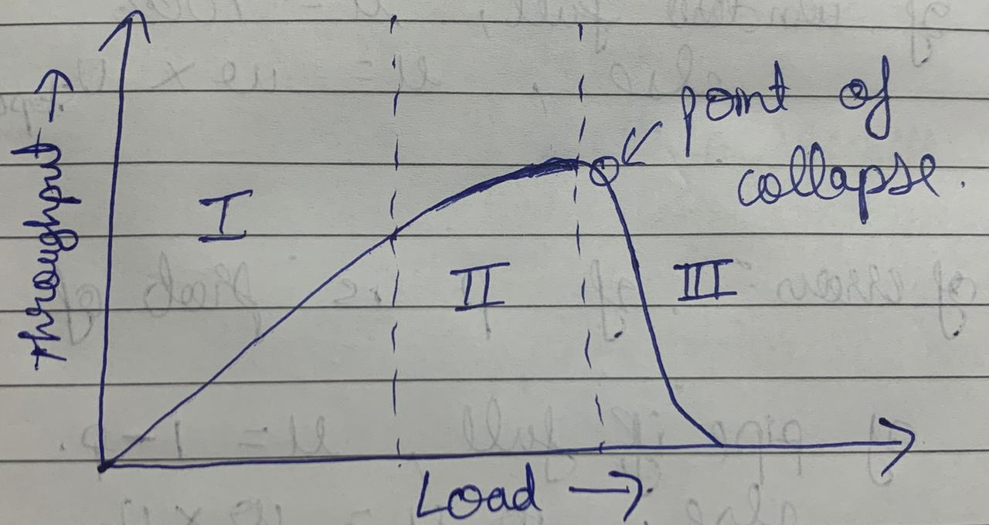

1. The first phase in the graph is the no congestion phase. Here the network performance is near ideal.

The second phase is the moderate congestion phase. Here the throughput goes down a little due to retransmissions and transmission of control packets. However, some of the data packets can still be sent because not all the routes are congested in the network.

The third phase is the serious congestion phase. Here almost all routes are congested and losses of packets occur very frequently which leads to retransmissions and as a result more timeouts which increases the load on the network and it gets even more congested. This is why congestion collapse happens.

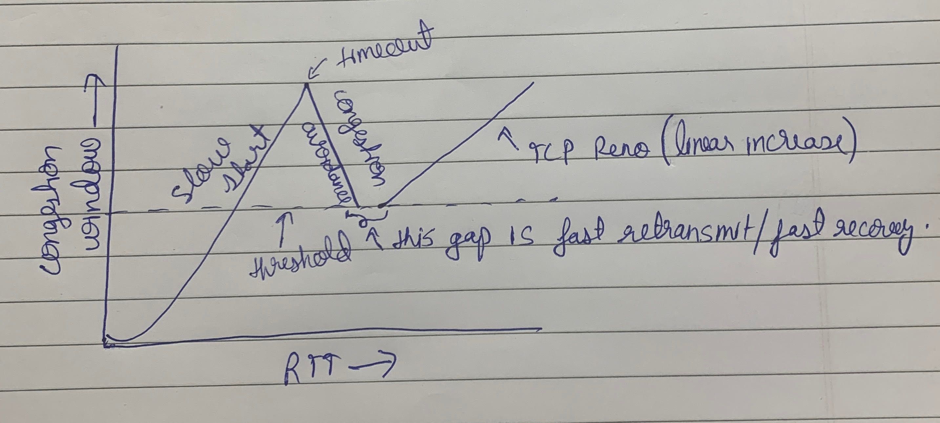

1. TCP operates somewhere in between of phase 2 so that it is neither underutilizing the network and nor overloading it. When the connection initially begins the congestion window is increased exponentially (1,2,4,8,16…) this is known as slow start. After reaching a certain threshold when a loss is encountered, it remembers the threshold and starts the congestion window from 1 to the threshold by using slow start. Once it reaches the threshold from there on it grows linearly with 1 increment every RTT. This is the congestion avoidance phase. There is a phase in between when we’re not sure whether it is a moderate or a severe congestion. Fast retransmit-fast recovery responds quickly to packet losses by retransmitting packet when 3 duplicate acks are received. If it was a mild congestion the retransmission will take care of it and will avoid a timeout. The slow start threshold becomes half of the congestion window and the segment is retransmitted with congestion windows size of ssthresh+3 and whenever a duplicate ack is received it is increased by 1 with the left side staying frozen. After the receiver gets the ack the congestion window becomes equal to the slow start threshold.

Q11- TCP interaction with routing: Argue for or against the following statement: “Packets are lost only when network failures occur (e.g., a link goes down). But when the network heals (e.g., the failed link comes back up again), packets do not get lost.”

[Hint: Write ~4-6 lines/sentences]

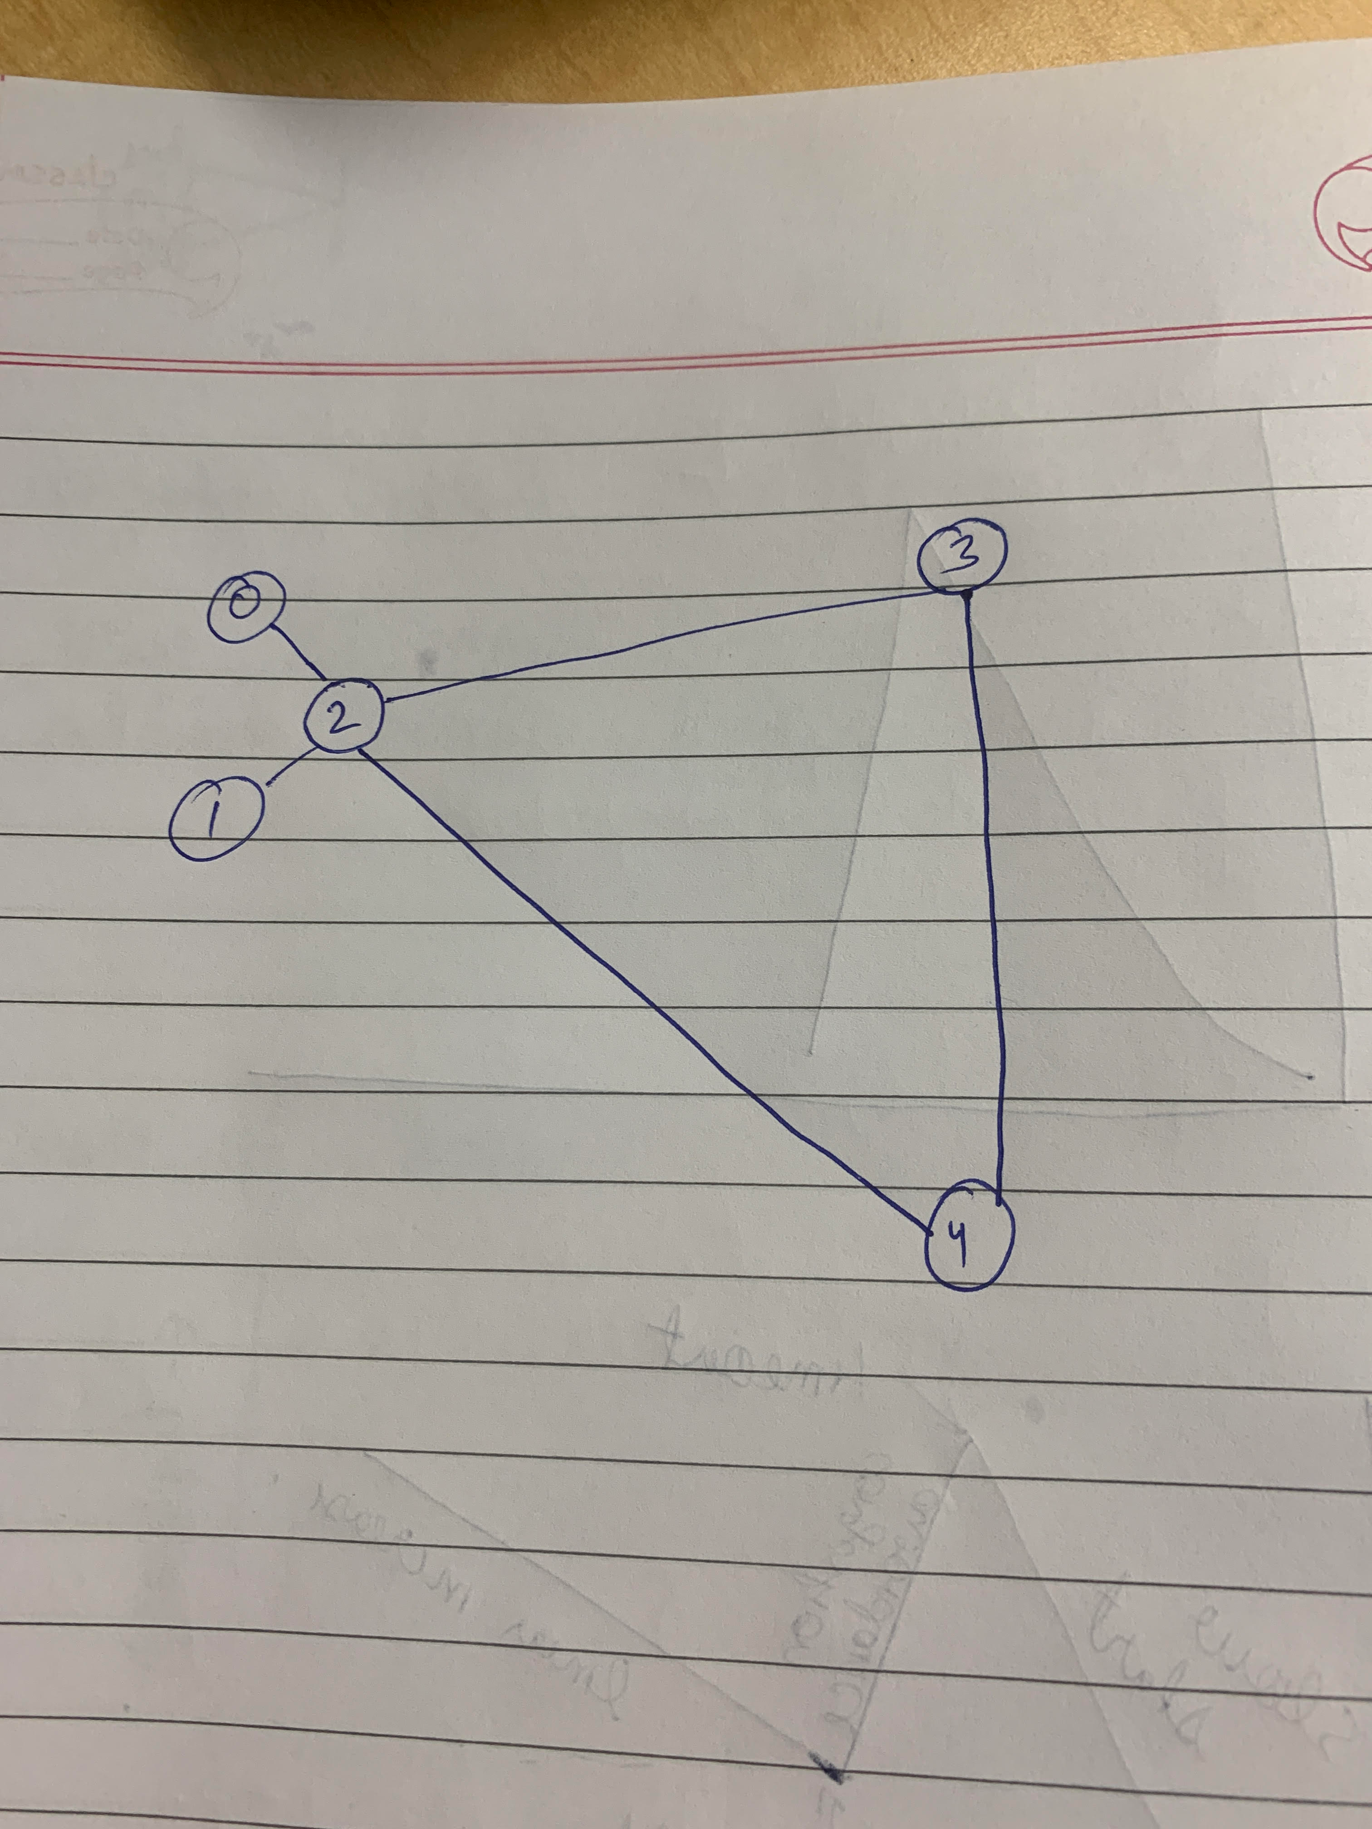

A11- Consider a scenario where there are two different flows. In the above diagram, the first flow goes from 1 to 3 (through 2) initially using slow start. But when the link goes down it experiences losses and goes into congestion avoidance and the packets get routed from 2 to 4 to 3 because the other link is down. Now the second flow starts from 0 to 3 (through 4) and uses slow start initially. Because the 2-4-3 route is longer and has a larger delay bandwidth product than the previous route both the flows increase their window size to the maximum delay bandwidth product and as the second flow is in slow start it is doing it much faster. As a result, second flow has a larger number of packets in the pipe. However, once the first link heals, the second route experiences massive losses because it opened the window size to adjust to the longer route and now is routed through the shorter route. This is good for reducing the delays, but it isn’t good for TCP and so the flow which didn’t experience any losses before, will lose packets once the link recovers. Hence, packets can be lost both when failure occurs or when the network heals.

[A *lab* part will be added to hwk2 later, to introduce socket programming and using tracing tools as relates to this homework. Instructions will be posted separately for the *lab* part.]